FUNDAMENTAL PARTICLES

Several hundred different particles have been discovered in particle accelerator experiments.

Particles are classified into two groups - hadrons and leptons.

• Hadrons - can be divided into baryons and mesons.

• Leptons - are elementary particles with no internal structure.

e.g. electrons, neutrinos.

Particles can be classified according to their spin.

• Fermions - have a half-integer spin (1/2, 3/2).

Baryons and Leptons are fermions.

Fermions obey the Pauli Exclusion Principle - any two fermions in the same quantum state cannot have the same quantum number.

• Bosons - have an integer spin (0, 1, 2, ...).

Mesons and photons are bosons.

Bosons do not follow the exclusion principle.

The following tables show the various properties of the common leptons, mesons and baryons.

Note

Photons are not listed in the table - they are field particles and are involved in interactions between particles.

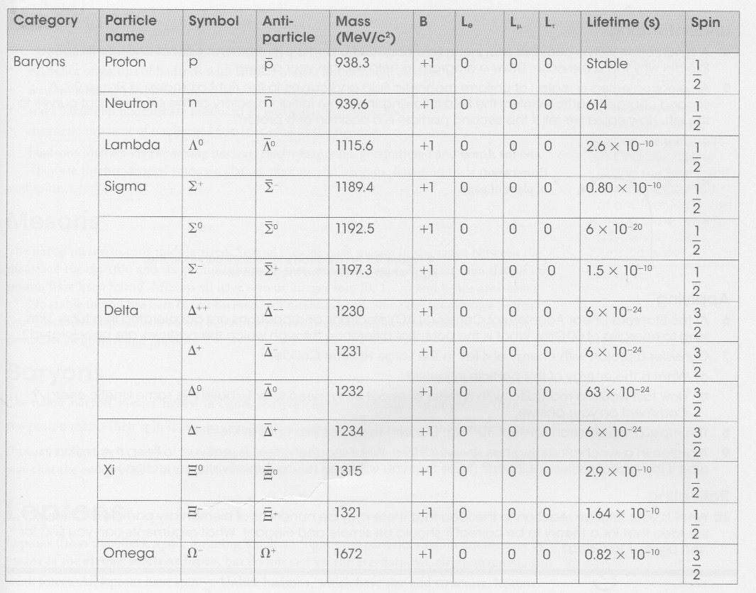
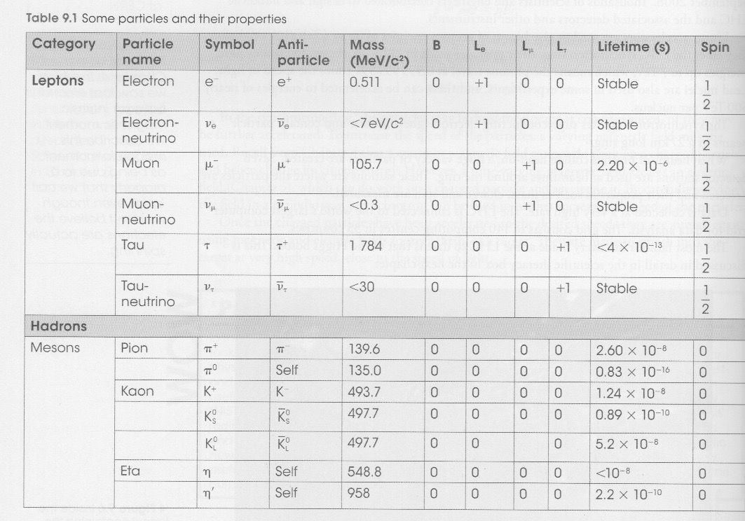

Summary

Hadrons

• Made up of three quarks.
• Interact via the strong nuclear, electromagnetic, gravitational and weak forces.
• Divided into mesons and baryons

Mesons

• Have integer spins (0, 1, 2, ...).
• Are bosons.
• No stable meson exists - they all decay.
• Meson decay produces electrons, positrons, neutrinos and photons.

Baryons

• Mass equal or greater than a proton.
• Have half-integer spins (1/2, 3/2).
• Protons and neutrons are baryons - protons are the only stable ones.

Leptons

• Don't interact via the strong nuclear force - only the other three.
• All have spin 1/2.
• Have no internal structure and are point-like.

Field particles

• The four fundamental forces are mediated by a field particle or exchange particle.

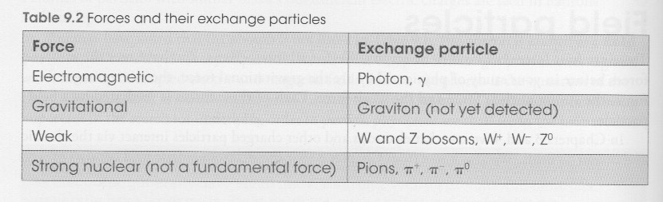

Conservation of Charge and Quantum Numbers

The quantum number for charge is conserved in particle decays.

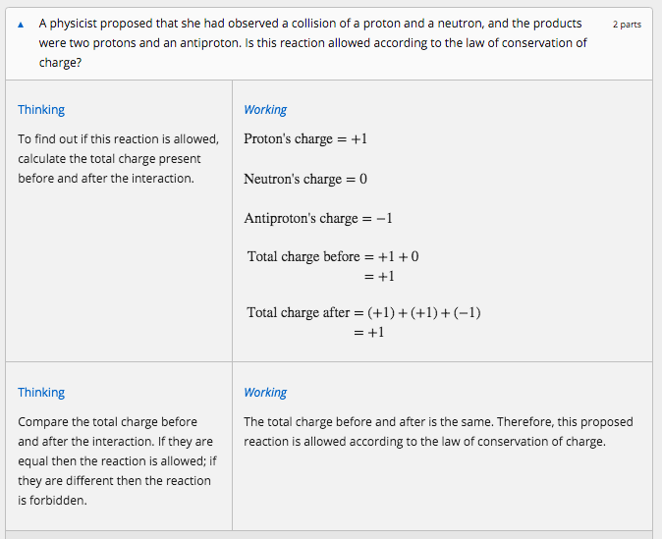

Conservation of Baryon Number

Baryons are all composite particles containing combinations of three quarks.

e.g. Protons and neutrons.

All baryons are given a quantum number - B = +1.

For antibaryons - B = −1.

For all of other particles involved in the interaction or decay - B = 0.

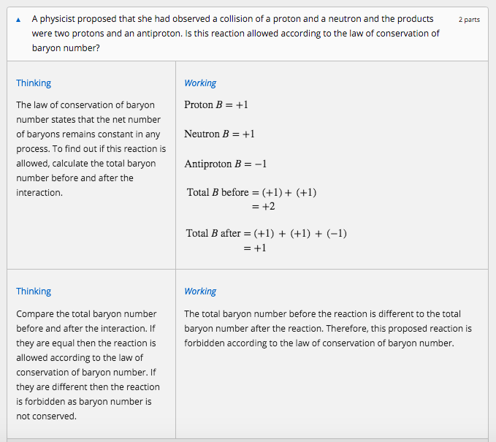

Conservation of Lepton Number

Leptons are the fundamental particles shown below.

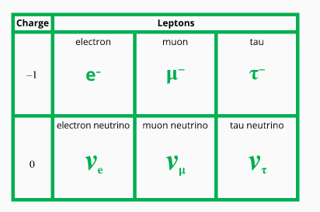

Lepton number, L, is a quantum number with value of +1 for leptons, −1 for antileptons and 0 for other particles.

There are actually three types of lepton numbers: one type for the electron and the electron neutrino, L_{e}; one type for the muon and the muon neutrino, L_{μ}; and one type for the tau and the tau neutrino, L_{τ}.

Each of these three lepton numbers must be considered and conserved independently. Both must be conserved for the reaction to be allowed.
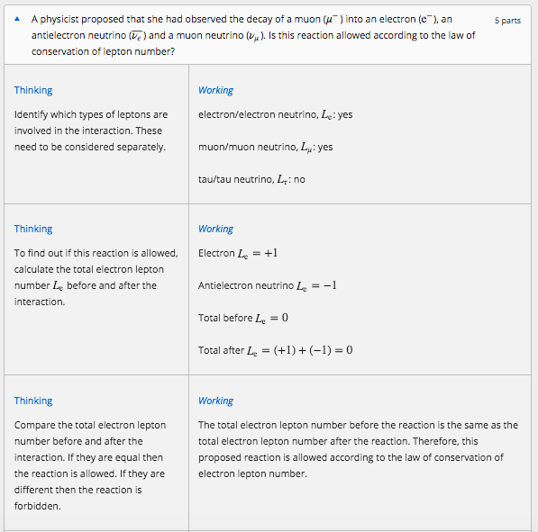
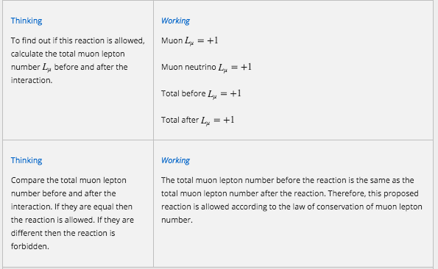

INTERACTIONS BETWEEN PARTICLES

Interactions between particles that produce some change and are observed by a particle detector are commonly known as events.

Those interactions that result in the formation of new particles are sometimes referred to as reactions.

Interactions can involve attractive or repulsive forces, decay or annihilation.

Examples

An example of a repulsive interaction involving the electromagnetic force would be the scattering of one electron by another.

This example is illustrated below using a diagram called a Feynman diagram.

It shows two electrons approach each other (on the horizontal axis) over time (the vertical axis) and exchange a photon.

This causes each electron to be repelled and therefore change direction.

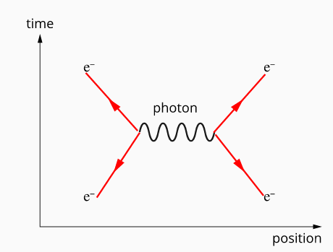

An example of a decay is the decay of a neutron into a proton.

This involves the weak nuclear force and is brought about by the conversion of a down quark in the neutron into an up quark.

This requires the emission of a W− boson, which decays into an antielectron neutrino and an electron.

This is commonly known as a beta-minus radioactive decay.

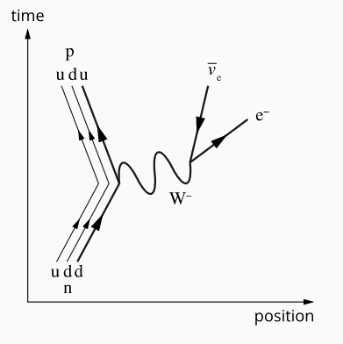

Note

It is important to note that the directions of the arrows in these diagrams do not indicate the direction a particle travels.

e.g. An antiparticle moves backwards in time.

Particles are represented by straight lines - the direction of the arrow represents the direction of time.

For antiparticles - the direction is reversed.

Wiggly lines represent massless exchange particles such as photons.

